Project Overview – Spry Web Browser

Current Situation
Current browser software for desktop PC's are extremely resource intensive. Firefox and Internet Explorer require large amounts of RAM, disk space, and CPU cycles in order to function well. Therefore, due to the nature of TechSol's products (low power, small foot print), these existing browsers do not provide a workable solution.
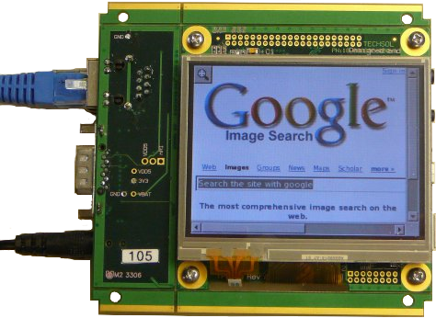
In the embedded space there are many open source browsers but all with minimal functionality and ongoing development. There are commercial browsers available, targeted at the embedded space (Opera), but all involve ongoing licensing fees.
WebKit is the one open source browser project that has; broad based support from the open source community, significant ongoing development, a focus towards hand held devices (low power, small footprint), both open source and commercial applications based on it, and, industry support with major contributions (Apple: Apples Safari browser, for the desktop and the iphone have been developed using WebKit).

Problem – Existing Software Solutions
- Resource intensive
- Some require ongoing licensing fees
- Large memory footprint
- Too many unnecessary features
- Unfriendly to touch-screen interfaces

Envisioned Implementation
- WebKit based browser
- Reimplement only the features WebKit/GTK+ that are absolutely necessary
- Provide command-line options to configure browser sessions
- Absolute minimum feature set

Implemented Ideas
- WebKit based browser
- Implemented WebKit/GTK+ as our API
- Provided a completely command-line configurable application
- Minimum feature set achieved via disabling WebKit/GTK+ features at compile time

What did not work (and why)
- Reimplementing only necessary features of WebKit/GTK+ – After digging through the source code of WebKit/GTK+, we found that it wouldn't be feasible to do a complete reimplementation of the project within the time-frame of this project.

What did work
- Creation of a WebKit based browser
- Using WebKit/GTK+ as our API
- Providing a completely command-line configurable solution.
- Reducing the browser's features to a minimum
- Reducing WebKit/GTK+ to a minimum through compile-time flags

Final Implementation and Conclusion
The final implementation of the Spry web browser uses WebKit/GTK+, which is a port of WebKit for Gtk+ on *NIX platforms. In theory, the Spry web browser could be compiled on Mac OS X or even Windows, given that the appropriate libraries and environments were installed.
When we initially started working on this project, we decided that the optimal solution would be one in which we actually took WebKit/GTK+ itself apart and only reimplemented the features contained therein that were absolutely necessary. By doing it this way, we could remove all the extra features that would not be used on a touch-screen as well as implement features that WebKit/GTK+ wouldn't be able to manage; such as click+drag to scroll the window.
Unfortunately, WebKit/GTK+ is very tightly integrated into the WebKit core, which made such a solution somewhat outside the scope of a 4-week project. As such, we decided to simply make use of the WebKit/GTK+ API in our solution.

WebKit/GTK+
WebKit/GTK+ is the new GTK+ port of the WebKit, an open-source web content engine that powers numerous applications such as web browsers, email clients, feed readers, web and text editors.
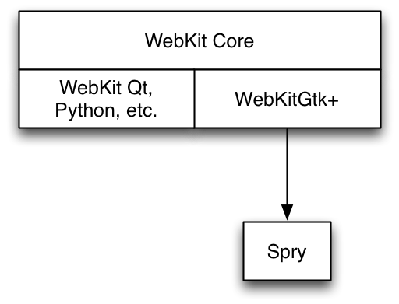
The WebKit/GTK+ port of WebKit is built upon the main WebKit Core and acts as somewhat of a go-between for Gtk+ and the WebKit Core. There are other WebKit projects that are also built upon the WebKit core, which include WebKit for Qt, Python, Cocoa, etc.
Spry is built upon WebKit/GTK+, which drastically reduced the amount of code complexity needed to build a fully-functional application, however, this also reduces the amount of control we have over what features of the WebKit Core to which the Spry web browser has access.
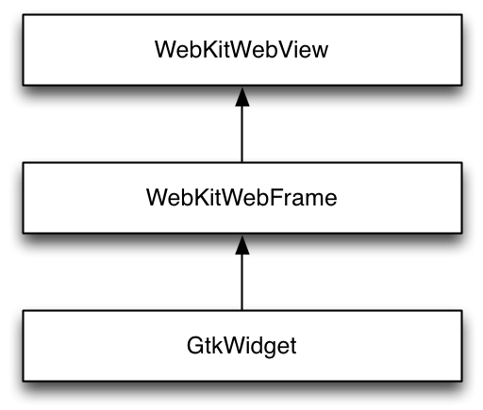
The object model for the actual web-browser contents in Spry is a simply hierarchy, similar to the API layers for WebKit/GTK+. The WebKitWebView object is the object that actually contains the web page content that a user actually sees. The WebKitWebView object is contained within a WebKitWebFrame object, which is subsequently contained within a standard GtkWidget object.

Implemented Functions
Because we decided to create the Spry web browser using the WebKit/GTK+ API, we actually only ended using three basic functions from the API. The remaining functions within the Spry web browser are all used to manage command-line options and GUI elements.
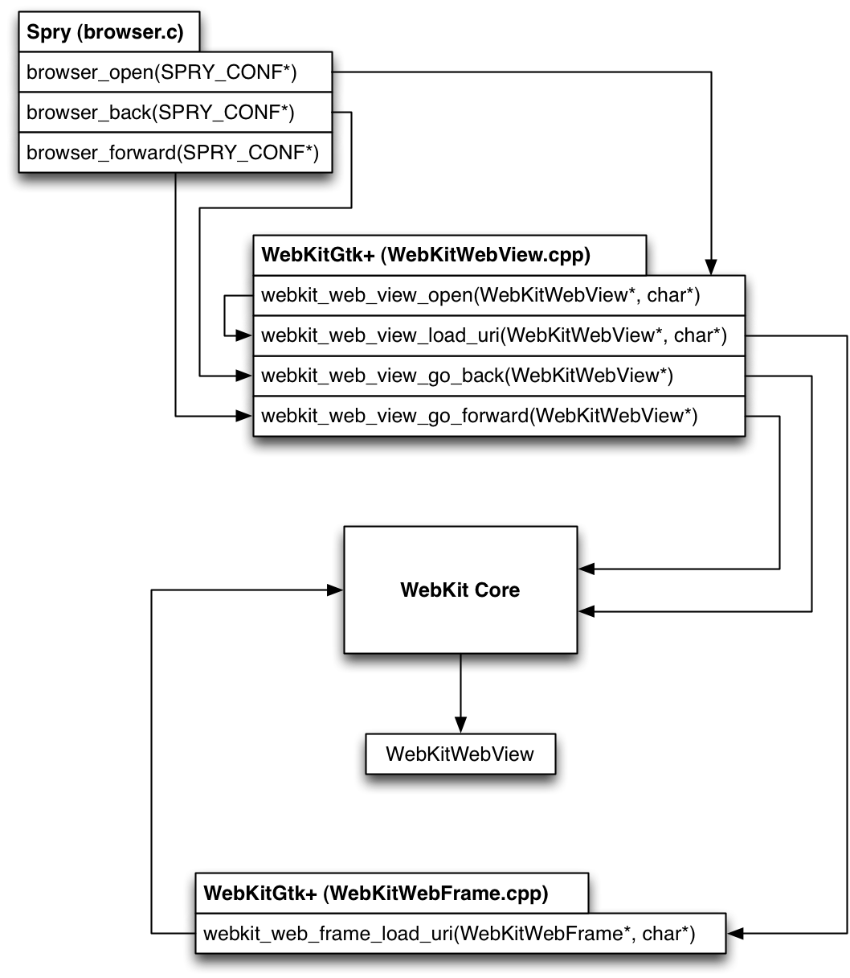

Functionality of Functions
As we mentioned above, very few of the WebKit/GTK+ API functions were actually needed to create a working web browser. Below I shall trace through what each function does.
Opening a new web page:
- browser_open(SPRY_CONF*) – Passes the WebKitWebView object contained within the SPRY_CONF struct and requested URI to the webkit_web_view_open() function.
- webkit_web_view_open(WebKitWebView*, char*) – This function has actually been depreciated in newer versions of WebKit/GTK+, which is why this function only serves to pass the WebKitWebView object and URI to the webkit_web_view_load_uri() function.
- webkit_web_view_load_uri(WebKitWebView*, char*) – This is the actual function that serves as a connector between WebKit/GTK+ and the WebKit Core. This function simply calls the appropriate WebKit Core object function with the WebKitWebFrame object (remember that WebKitWebFrame contains the WebKitWebView object) and URI string. The WebKit Core then loads the requested page data into the WebKitWebFrame, which is then immediately updated within the GUI.
Going backwards in the browser history:
- browser_back(SPRY_CONF*) – Passes the WebKitWebView object contained within the SPRY_CONF struct to webkit_web_view_go_back() function.
- webkit_web_view_go_back(WebKitWebView*) – Much like with browser_open(), the WebKit/GTK+ API simply passes the WebKitWebFram contained within WebKitWebView to the WebKit Core to be populated with the previous web page's data.
Going forwards in the browser history:
- browser_forward(SPRY_CONF*) – Passes the WebKitWebView object contained within the SPRY_CONF struct to webkit_web_view_go_forward() function.
- webkit_web_view_go_forward(WebKitWebView*) – Passes the WebKitWebFram contained within WebKitWebView to the WebKit Core to be populated with the next web page's data.

Downloading & Compiling WebKit/GTK+
We first started working with WebKit SVN repository, however, we soon found out that compiling from that repository would take hours and create a very large WebKit library file. As such, we have switched to the latest current release of WebKitGtk+, which can be obtained from the WebKitGtk+ project website (http://webkitgtk.org/).

Obtaining WebKit
There are several options for obtaining WebKit/GTK+, however, I highly suggest the first option, as checking out WebKit from the SVN or Git trunk can be very time consuming. Additionally, the download of WebKit/GTK+ 1.1.7 has all of the non GTK+ related code removed from the source, speeding up compile times tremendously while also reducing the resultant library size.
- Download the current release of WebKit/GTK+:
WebKit/GTK+ 1.1.7 - http://www.webkitgtk.org/webkit-1.1.7.tar.gz
- Or checkout the current development version of WebKit from SVN:
svn co http://svn.webkit.org/repository/webkit/trunk
- Alternatively there is a git mirror for your convenience:
git clone git://git.webkit.org/webkit

Compiling WebKit/GTK+ on Ubuntu 8.04
Once you have obtained and extracted WebKit/GTK+, you'll need to make sure you have the all of the required packages installed before being able to compile.
For Ubuntu 8.04, install the following packages:
- build-essential
- gnome-common
- pkg-config
- bison
- flex
- gperf
- libjpeg-dev
- libpng12-dev
- libglib2.0-dev
- libicu-dev
- libxml-dev
- libxslt1-dev
- libpango1.0-dev
- libenchant-dev
- libgtk2.0-dev
- libxt-dev
- libsqlite3-dev
- gtk-doc-tools
There is one snag with Ubuntu 8.04, as the version of libsoup is too old to work with the current release of WebKit/GTK+. As such, you will need to download the latest version of libsoup and compile and install that before continuing with compiling WebKit/GTK+ itself.
Obtaining & Compiling libsoup >= 2.25.91:
- git clone git://git.gnome.org/libsoup
- cd libsoup
- ./autogen.sh –without-gnome
- sudo make install
Compiling libsoup with the --without-gnome flag is important, otherwise libsoup will require you to install libraries that are unavailable to Unbutu 8.04.

Compiling WebKit/GTK+ on Ubuntu 9.04
After having obtained and extracted WebKit/GTK+, you'll need to make sure you have the all of the required packages installed before being able to compile.
For Ubuntu 9.04, install the following packages:
- build-essential
- gnome-common
- pkg-config
- bison
- flex
- gperf
- libjpeg-dev
- libpng12-dev
- libglib2.0-dev
- libicu-dev
- libxml2-dev
- libxslt1-dev
- libpango1.0-dev
- libenchant-dev
- libgtk2.0-dev
- libxt-dev
- libsoup2.4-dev
- libsqlite3-dev
- gtk-doc-tools

Flags that Work
- --with-target=x11 – Sets the build target to X11
- --with-font-backend=freetype – Freetype isn't as large as using pango
- --enable-optimizations – Enables all compiler optimizations
- --enable-fast-malloc – Enalbles the use of fast mallocs
- --enable-jit – Enables the JIT compiler for JavaScript.
This is what makes WebKit's JS so fast
- --enable-static – Enables static compilation
- --disable-largefile – Disables support for large files
- --disable-libtool-lock – Disables libtool locking. This speeds up
compilation, but may break parallel builds.
- --disable-debug – We don't want debugging enabled
- --disable-dashboard-support – OS X specific support
- --disable-offline-web-applications – Disables storing web-applications for
offline use
- --disable-dom-storage – Disables HTML5 DOM storage
- --disable-icon-database – Disables sqlite icon database
- --disable-video – Disables HTML5 video support
- --disable-xpath – Disables XML Xpath support
- --disable-xslt – Disables XML stylesheet support
- --disable-geolocation – Disables geolocation support
- --disable-wml – Disables Wireless Markup Language
- --disable-web-workers – Disables offloading JavaScript to a thread
- --disable-coverage – Disables code coverage support
- --disable-svg-animation – Disables experimental SVG animation
- --disable-svg-filters – Disables experimental SVG filters
- --disable-svg-fonts – Disables experimental SVG fonts
- --disable-svg-foreign-object – Disables experimental SVG objects
- --disable-svg-as-image – Disables experimental SVG as image
- --disable-svg-use-element – Disables experimental SVG as element

Flags that Cause Compilation to Fail
- --with-target=directfb – Attempts to compile WebKit/GTK+ with
frame-buffer support
- --disable-database – Disables use of sqlite databases
- --disable-svg – Disables SVG support
- --disable-javascript-debugger – Disables the JavaScript debugger

Flags Used During Testing
After several days of compiling WebKit/GTK+ over and over, we were able to successfully build WebKit/GTK+ using the following compile-time flags:
./autogen.sh –with-target=x11 \
--with-font-backend=freetype \
--enable-optimizations \
--enable-fast-malloc \
--enable-jit \
--enable-static \
--disable-largefile \
--disable-libtool-lock \
--disable-debug \
--disable-dashboard-support \
--disable-offline-web-applications \
--disable-dom-storage \
--disable-icon-database \
--disable-video \
--disable-xpath \
--disable-xslt \
--disable-geolocation \
--disable-wml \
--disable-web-workers \
--disable-coverage \
--disable-svg-animation \
--disable-svg-filters \
--disable-svg-fonts \
--disable-svg-foreign-object \
--disable-svg-as-image \
--disable-svg-use-element
These flags basically disable every feature of WebKit/GTK+ that we didn't foresee as being used or needed for a web browser running in an embedded environment. Our testing has shown that disabling all these WebKit/GTK+ features have no impact on normal web browsing. All of the pages that we tested worked as expected, including the test pages that TechSol provided.

WebKit/GTK+ Library Dependencies
Based on using the compile-time flags listed above, WebKit/GTK+ has the following library dependencies:
-rw-r--r-- 1 root root 42700 2008-10-10 12:36 /lib/libgcc_s.so.1
-rw-r--r-- 1 root root 95948 2008-02-29 14:29 /lib/libselinux.so.1
-rwxr-xr-x 1 root root 1364388 2008-09-12 07:33 /lib/tls/i686/cmov/libc.so.6
-rw-r--r-- 1 root root 9684 2008-09-12 07:33 /lib/tls/i686/cmov/libdl.so.2
-rw-r--r-- 1 root root 149328 2008-09-12 07:33 /lib/tls/i686/cmov/libm.so.6
-rwxr-xr-x 1 root root 112354 2008-09-12 07:33 /lib/tls/i686/cmov/libpthread.so.0
-rw-r--r-- 1 root root 30624 2008-09-12 07:33 /lib/tls/i686/cmov/librt.so.1
-rw-r--r-- 1 root root 104756 2008-03-10 15:39 /usr/lib/libatk-1.0.so.0
-rw-r--r-- 1 root root 396284 2008-06-04 08:45 /usr/lib/libcairo.so.2
-rw-r--r-- 1 root root 23132 2007-12-09 12:08 /usr/lib/libenchant.so.1
-rw-r--r-- 1 root root 131652 2007-12-05 09:51 /usr/lib/libexpat.so.1
-rw-r--r-- 1 root root 172592 2008-02-28 09:22 /usr/lib/libfontconfig.so.1
-rw-r--r-- 1 root root 447292 2009-04-22 11:24 /usr/lib/libfreetype.so.6
-rw-r--r-- 1 root root 94868 2008-09-26 06:28 /usr/lib/libgdk_pixbuf-2.0.so.0
-rw-r--r-- 1 root root 536872 2008-09-26 06:28 /usr/lib/libgdk-x11-2.0.so.0
-rw-r--r-- 1 root root 394976 2009-03-12 17:43 /usr/lib/libgio-2.0.so.0
-rw-r--r-- 1 root root 723948 2009-03-12 17:43 /usr/lib/libglib-2.0.so.0
-rw-r--r-- 1 root root 10116 2009-03-12 17:43 /usr/lib/libgmodule-2.0.so.0
-rw-r--r-- 1 root root 245296 2009-03-12 17:43 /usr/lib/libgobject-2.0.so.0
-rw-r--r-- 1 root root 14232 2009-03-12 17:43 /usr/lib/libgthread-2.0.so.0
-rw-r--r-- 1 root root 3628152 2008-09-26 06:28 /usr/lib/libgtk-x11-2.0.so.0
-rw-r--r-- 1 root root 86160 2007-10-23 22:08 /usr/lib/libICE.so.6
-rw-r--r-- 1 root root 11175612 2009-03-25 10:30 /usr/lib/libicudata.so.38
-rw-r--r-- 1 root root 1428992 2009-03-25 10:30 /usr/lib/libicui18n.so.38
-rw-r--r-- 1 root root 1203328 2009-03-25 10:30 /usr/lib/libicuuc.so.38
-rw-r--r-- 1 root root 125316 2007-10-01 07:36 /usr/lib/libjpeg.so.62
-rw-r--r-- 1 root root 244900 2009-05-05 12:12 /usr/lib/libpango-1.0.so.0
-rw-r--r-- 1 root root 34904 2009-05-05 12:12 /usr/lib/libpangocairo-1.0.so.0
-rw-r--r-- 1 root root 158380 2009-05-05 12:12 /usr/lib/libpangoft2-1.0.so.0
-rw-r--r-- 1 root root 157240 2008-07-09 10:23 /usr/lib/libpcre.so.3
-rw-r--r-- 1 root root 164328 2008-04-07 13:01 /usr/lib/libpixman-1.so.0
-rw-r--r-- 1 root root 141452 2009-03-05 11:34 /usr/lib/libpng12.so.0
-rw-r--r-- 1 root root 28092 2007-05-16 02:07 /usr/lib/libSM.so.6
-rw-r--r-- 1 root root 410036 2007-10-24 09:04 /usr/lib/libsqlite3.so.0
-rw-r--r-- 1 root root 970680 2008-10-10 12:39 /usr/lib/libstdc++.so.6
-rw-r--r-- 1 root root 944876 2008-03-11 13:33 /usr/lib/libX11.so.6
-rw-r--r-- 1 root root 6988 2007-04-27 09:03 /usr/lib/libXau.so.6
-rw-r--r-- 1 root root 93832 2008-03-11 13:31 /usr/lib/libxcb.so.1
-rw-r--r-- 1 root root 4172 2008-03-11 13:31 /usr/lib/libxcb-xlib.so.0
-rw-r--r-- 1 root root 6716 2007-12-06 03:54 /usr/lib/libXcomposite.so.1
-rw-r--r-- 1 root root 33152 2007-10-24 00:39 /usr/lib/libXcursor.so.1
-rw-r--r-- 1 root root 5992 2007-04-27 09:01 /usr/lib/libXdamage.so.1
-rw-r--r-- 1 root root 16616 2007-04-27 09:01 /usr/lib/libXdmcp.so.6
-rw-r--r-- 1 root root 56156 2007-07-24 01:00 /usr/lib/libXext.so.6
-rw-r--r-- 1 root root 14128 2007-04-27 08:59 /usr/lib/libXfixes.so.3
-rw-r--r-- 1 root root 6464 2007-07-25 01:01 /usr/lib/libXinerama.so.1
-rw-r--r-- 1 root root 29432 2007-10-24 00:43 /usr/lib/libXi.so.6
-rw-r--r-- 1 root root 1171112 2008-11-18 11:16 /usr/lib/libxml2.so.2
-rw-r--r-- 1 root root 22136 2007-10-24 01:31 /usr/lib/libXrandr.so.2
-rw-r--r-- 1 root root 30544 2007-10-24 01:31 /usr/lib/libXrender.so.1
-rw-r--r-- 1 root root 326564 2007-05-21 05:27 /usr/lib/libXt.so.6
-rw-r--r-- 1 root root 81240 2007-11-15 04:08 /usr/lib/libz.so.1
-rwxr-xr-x 1 root root 824448 2009-05-22 01:24 /usr/local/lib/libsoup-2.4.so.1
What we have failed to completely understand is why after disabling features such as XML and pango, they remain in the ldd listings for libwebkit. However, despite this large listing of libraries, I am sure that a fair amount of these libraries wouldn't be required when doing a cross compile.

Disabling WebKit/GTK+ Features
What we discovered throughout the course of creating the Spry web browser is that it is very difficult to disable features implemented within WebKit/GTK+ that we don't necessarily want.
For example, we struggled for a long time with how to disable the ability for the user to select and highlight text, as this could lead to undesirable behaviour in a touch-screen environment. Unfortunately, all of our attempted workarounds caused the browser to become unusable.

Reimplementation of WebKit/GTK+
Because of the above limitations, we came to the conclusion that our original development plan would have been the most optimal for this situations. It was also, unfortunately, beyond the scope of time that we had available for working on this project.
However, despite the limitation of time, I believe that it is entirely possible to reimplement only the necessary features of WebKit/GTK+ within a reasonable time-frame; perhaps a couple of months.
I therefore suggest that if TechSol is interested in further optimization of the Spry web browser, that they consider developing along this route.

Spry Web Browser

Required Libraries
The only library that the Spry browser itself requires is:
-rwxr-xr-x 1 root root 14285101 2009-05-22 03:20 /usr/local/lib/libwebkit-1.0.so.2
So basically, as long as the requirements for libwebkit are met, Spry shouldn't have any issues running on any platform.

Compilation
To compile the Spry web browser, do the following:
- ./autogen.sh
- make
- sudo make install
That should be all that is required to have a successful compile of the Spry web browser.

Gtk+ Documentation
Throughout the development of the Spry web browser, we adhered to the Gtk-Doc standards such that easy to read HTML documentation could be produced for the code on demand.
Generating Gtk-Docs:
- In the Spry source directory, enter ./mkdoc.sh
- cd docs
- Open index.html
More information about Gtk-Doc can be found at:
- http://library.gnome.org/devel/gtk-doc-manual/stable/

